National University of Computer and Emerging Sciences, Lahore Campus

 | Course: | Digital Logic Design | Course Code: | EE227
 | Program: | BS(Computer Science) | Semester: | Fall 2018
 | Duration: | 25 Minutes | Total Marks: | 10
 | Quiz Date: | 12-12-18 | Weight:
 | Section: | A | Page(s):
 | Exam: | Quiz-5 | Roll Number

Show your working otherwise no credit will be given.
Q1. Design a counter with the following binary sequence 0,1,3,2,4,5,7. Use SR
flipflops. (10marks)

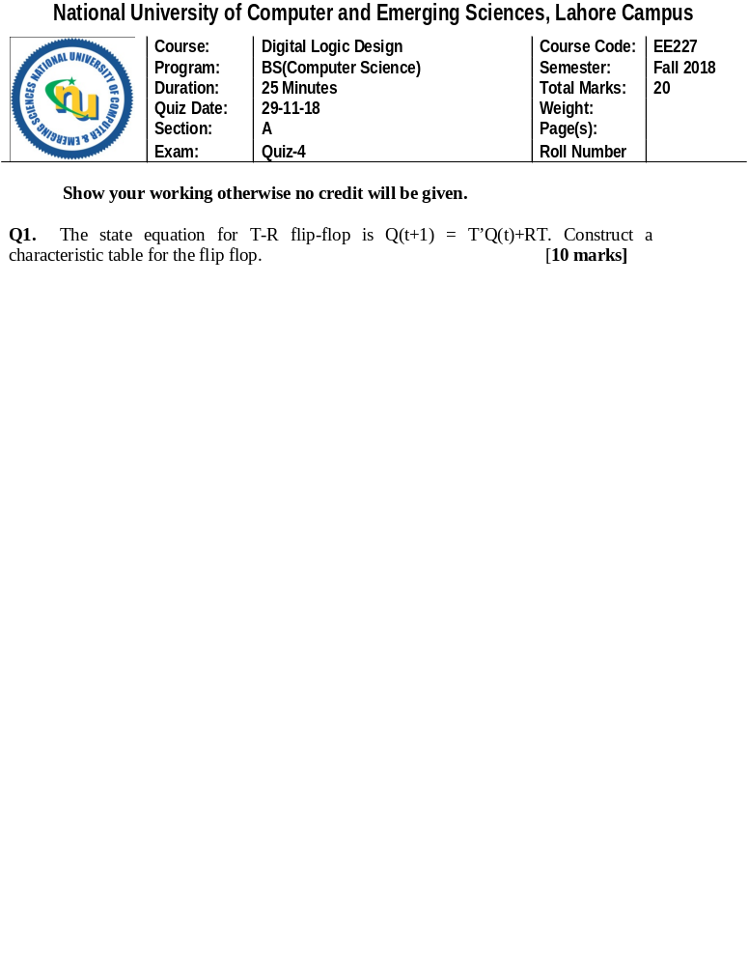

Q2 (a). What should be the logical value of clock Pulse (CP) at the time of enabling the
flip-flop whose diagram is shown below? [10 marks]

Nand
A Q

CP
Nand
Q
B

CP = _________

(b) Fill the characteristic table of the above flip flop.

CP | A | B | Q(t+1)

